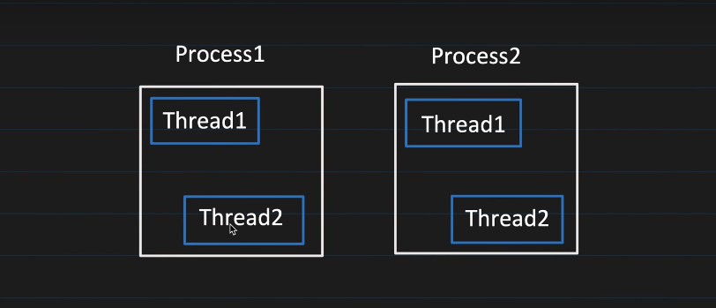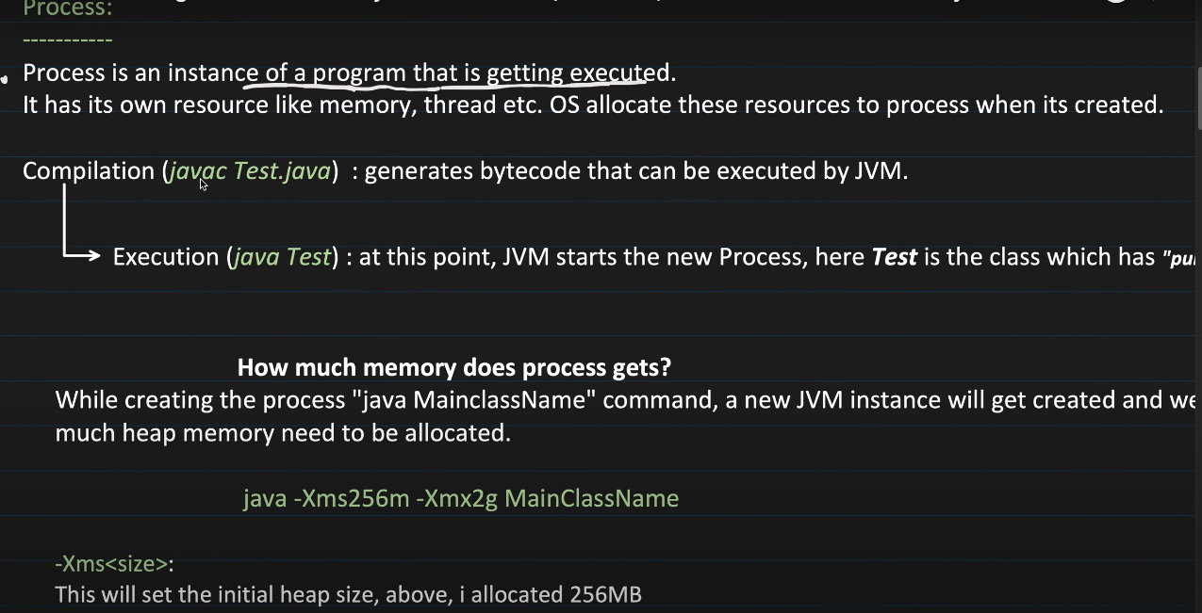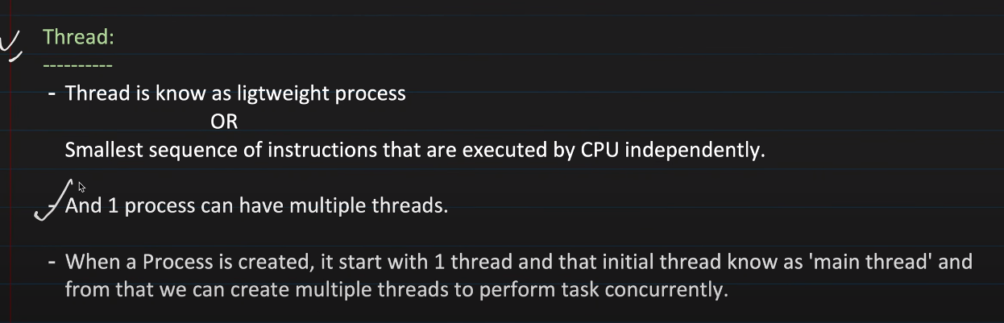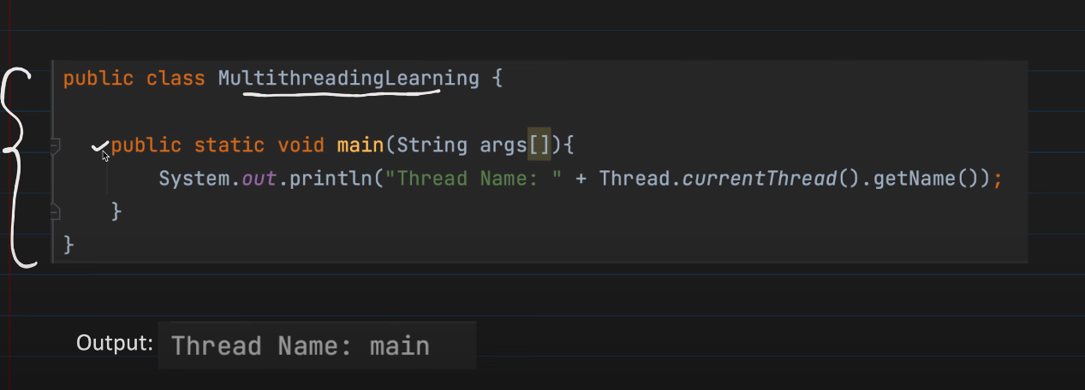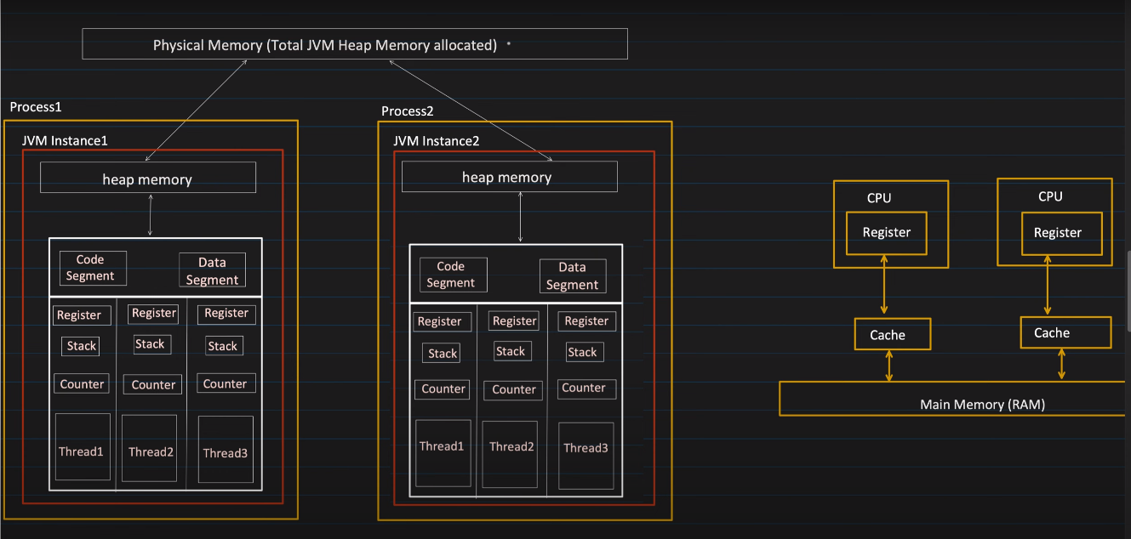Lets say jvm has 10gb of memory then each instance has to define the min and max memory it will require for the program execution. 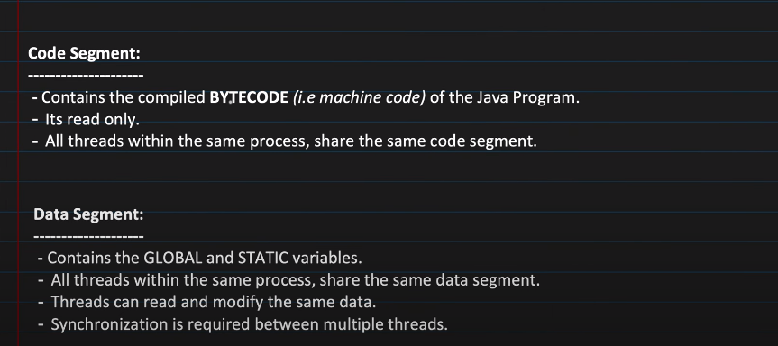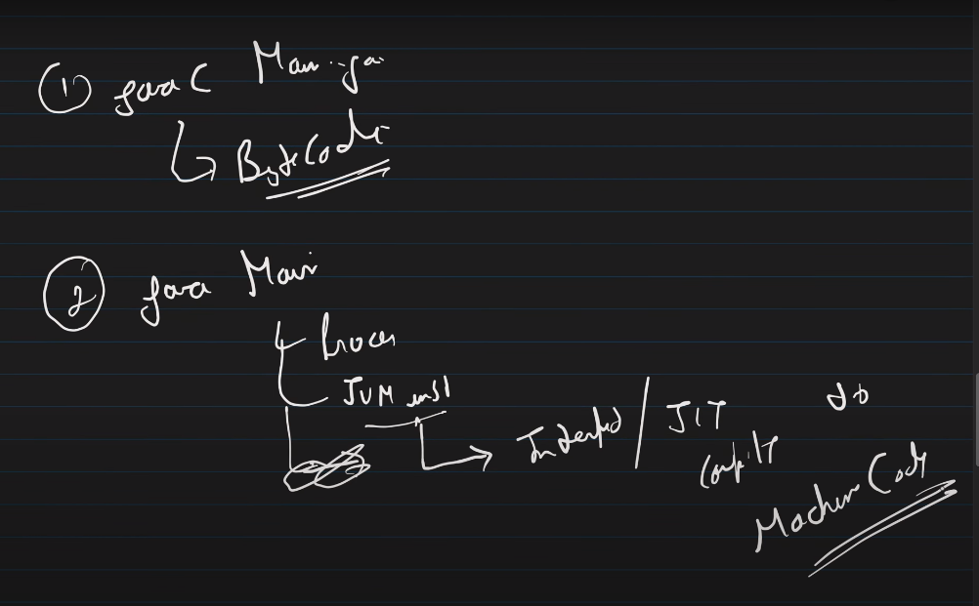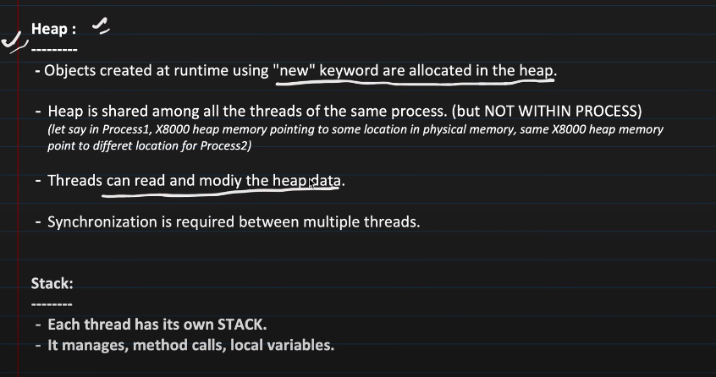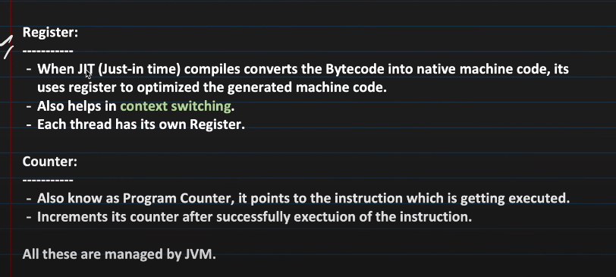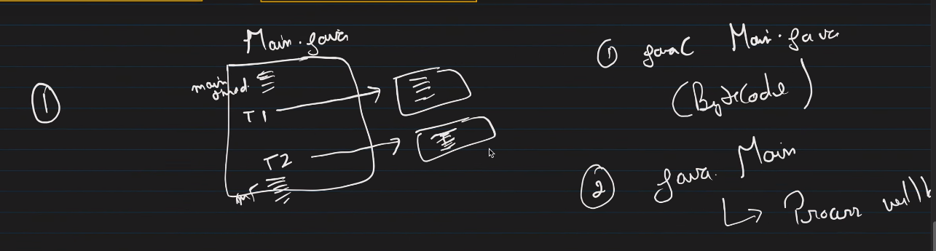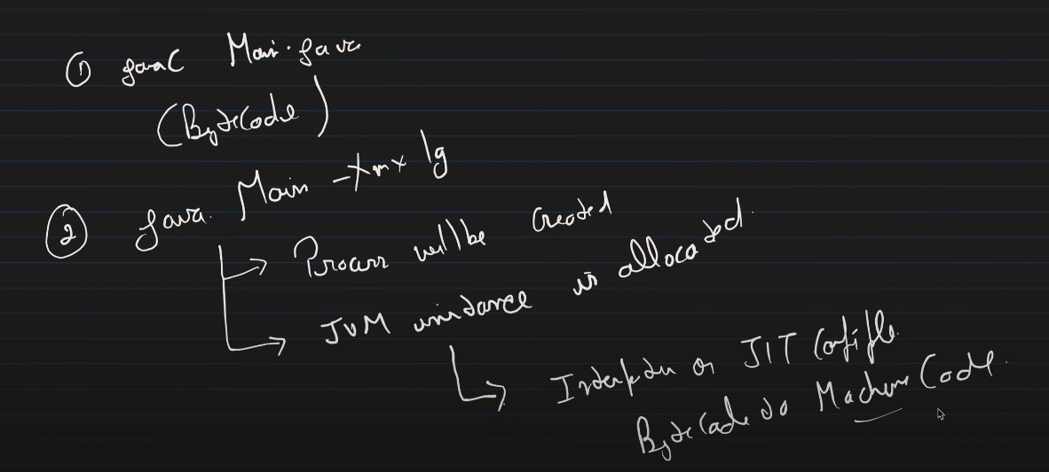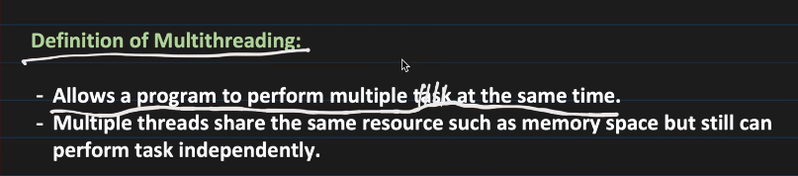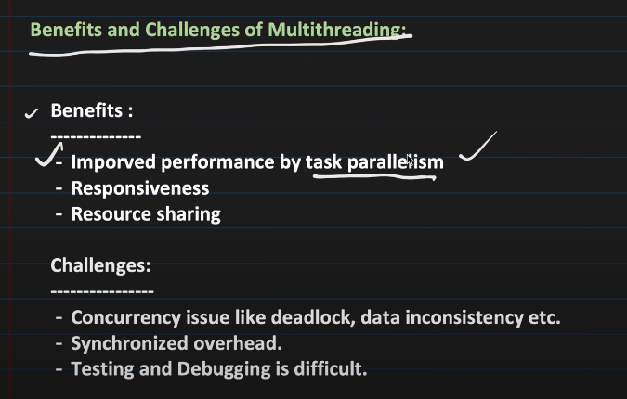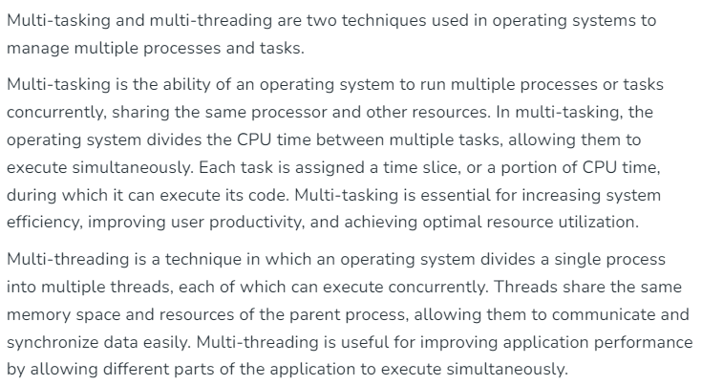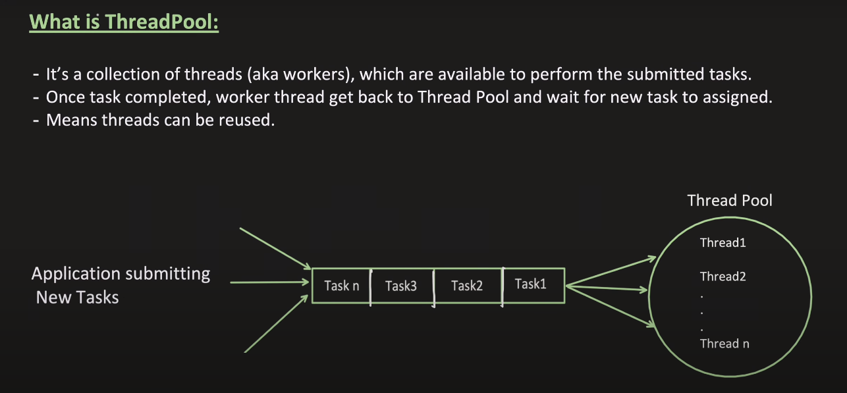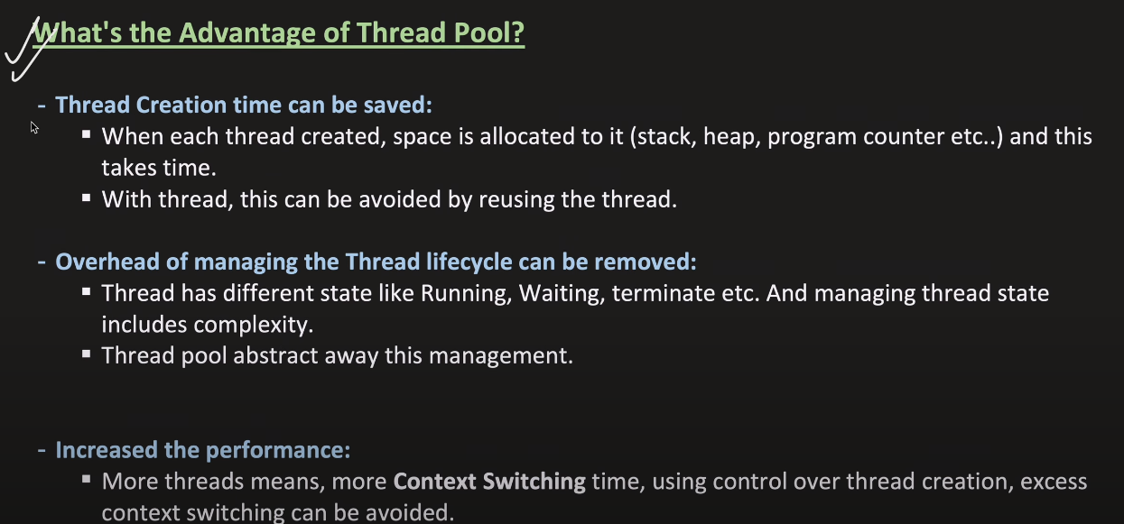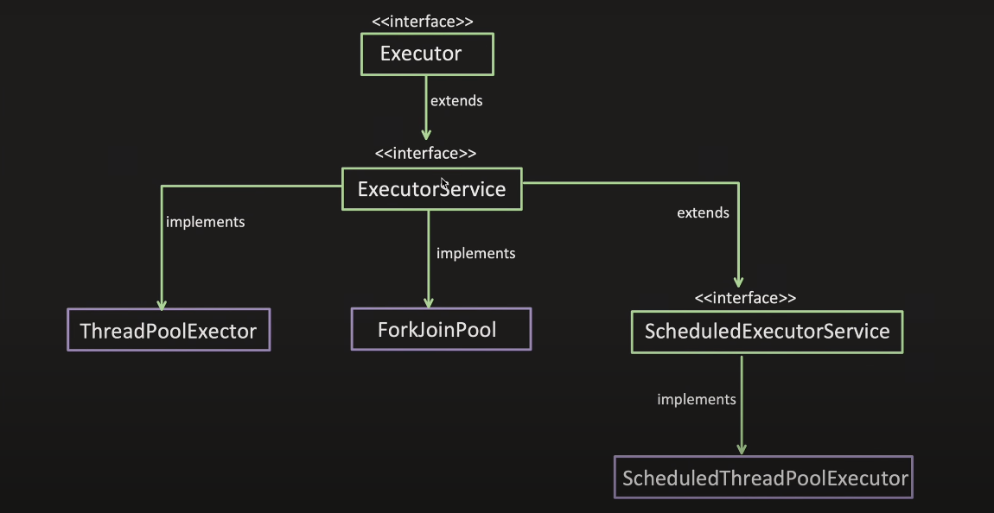when we execute threadpool executor then it creates the thread defined as minimum number of threads lets say 3 then it will create the 3 thread and we can define the max number of thread my thread pool can have lets say 5 and queue capacity also as 5 when my all minumum threads are occupied then every other upcoming task are placed inside the queue and when queue is also filled and some other task comes then executor will check using max number of thread it can create is there any scope of creating new thread in our case we can have max uoto 5 threads so it will create one more thread in the pool and assign that task tio the thread and if one more task comes and by checking it will create one more thread and allocate that thread to that task and now queue is full and all the max number of threads are occupied so if some other task comes then it will be rejected. 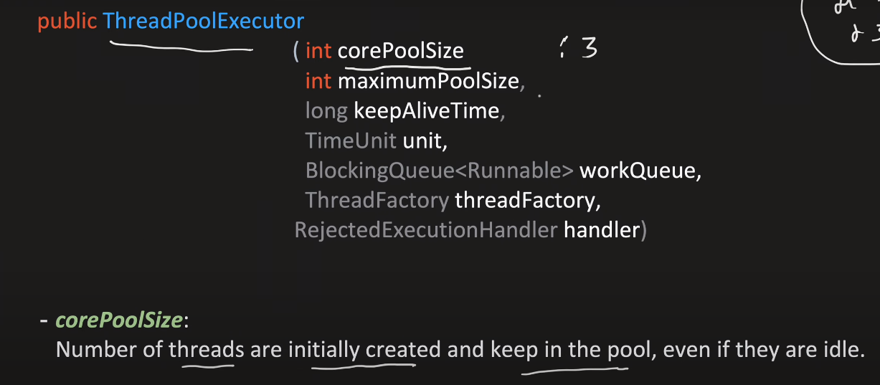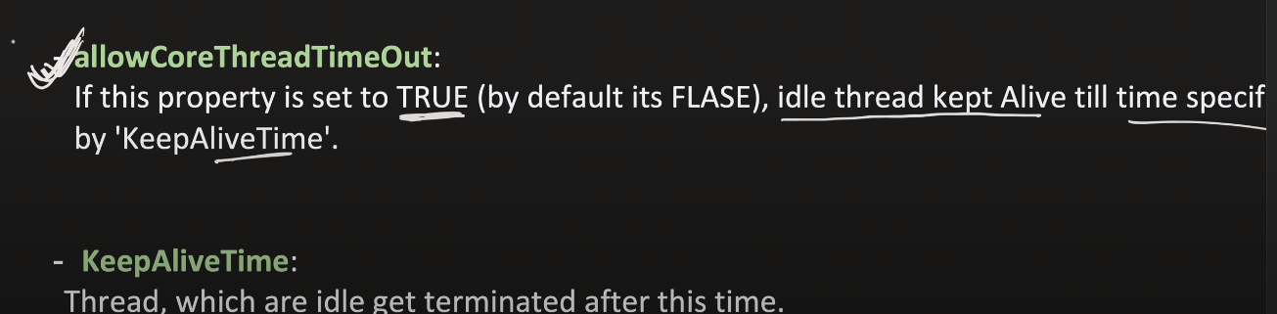if allowCoreThreadTimeOut is set true then after keepAliveTime these thread are terminated if are idle. 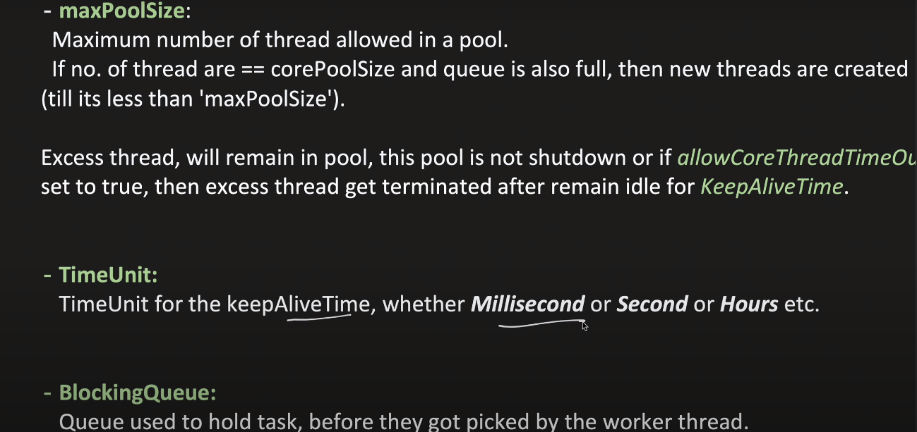When all minumim threads are occupied then why we don’t create threads upto max number of threads and keep them into queue because after using that thread will be put back into the pool and we have defined on average we have minumum number of threads in pool is defined in the bean. 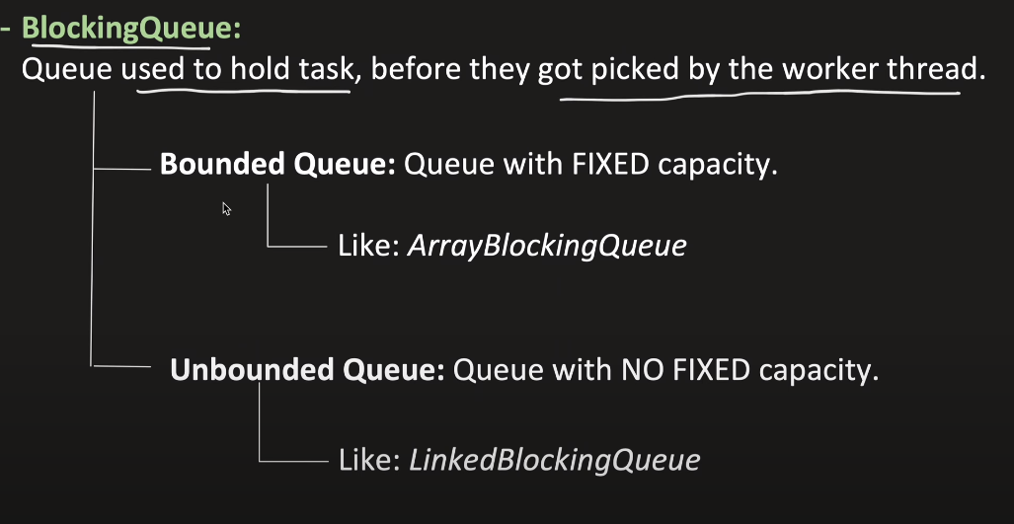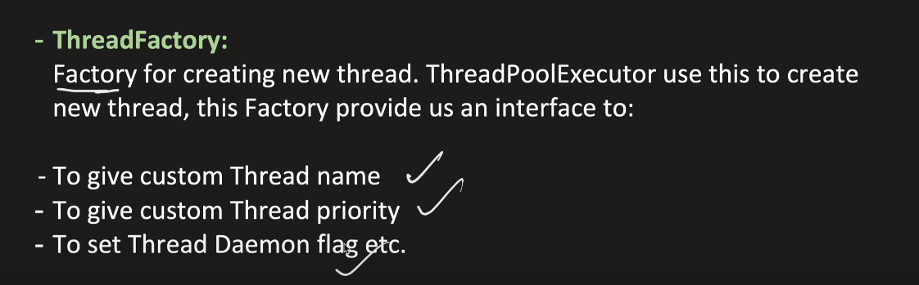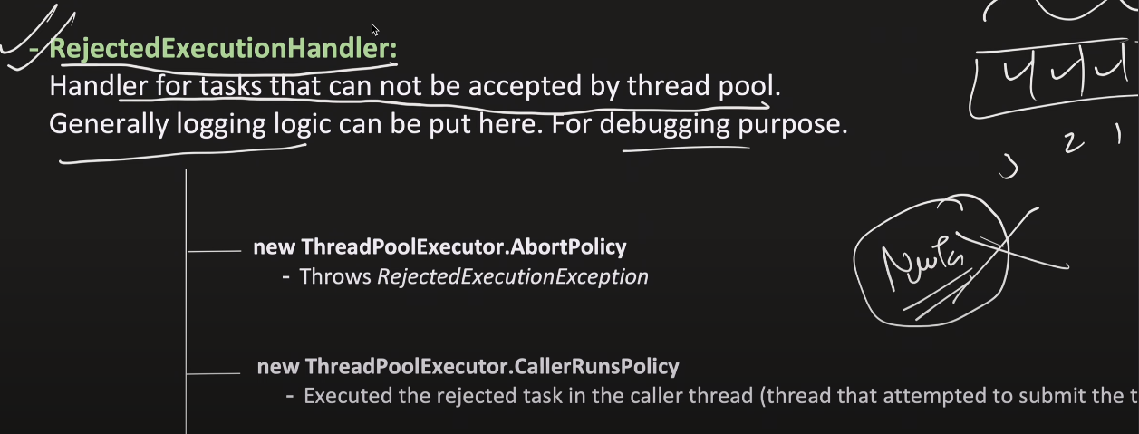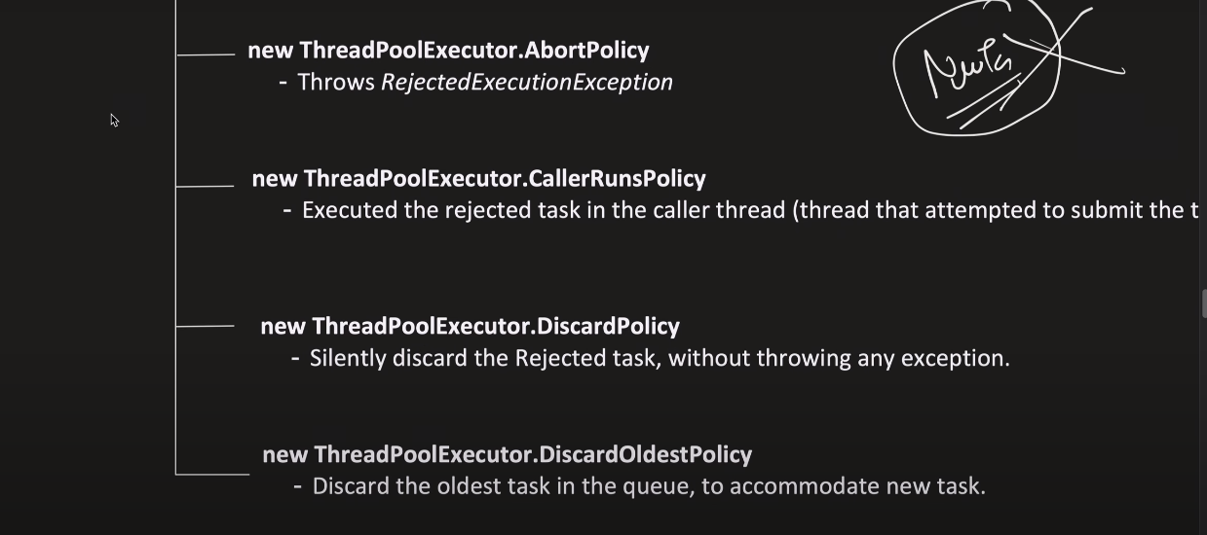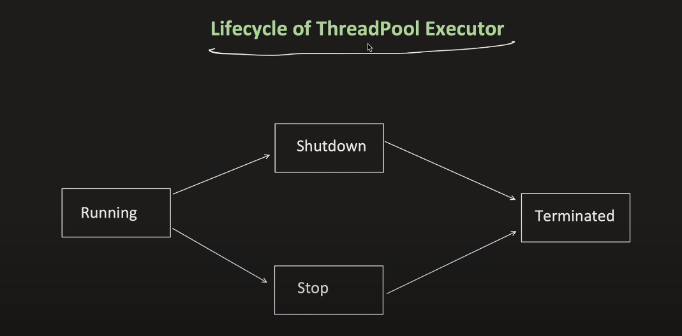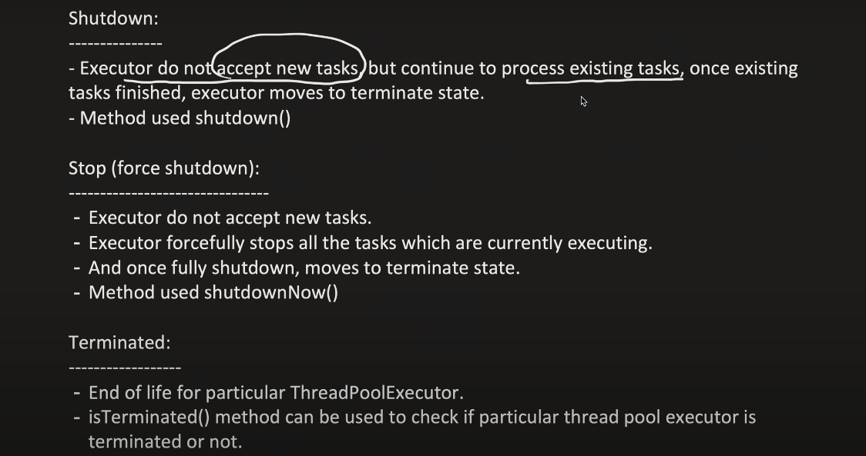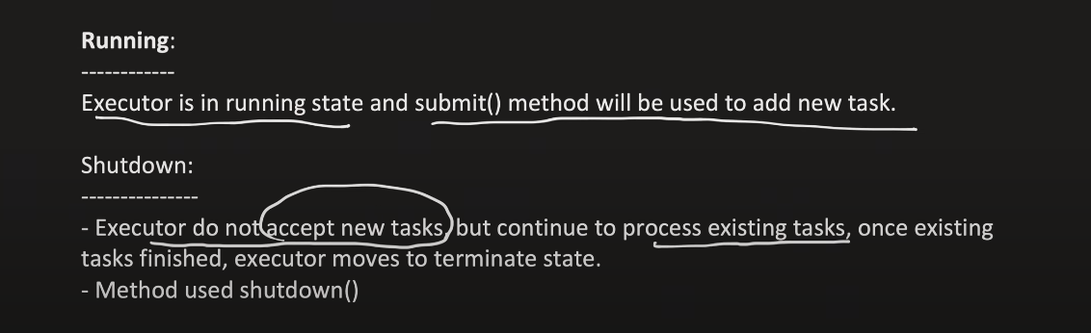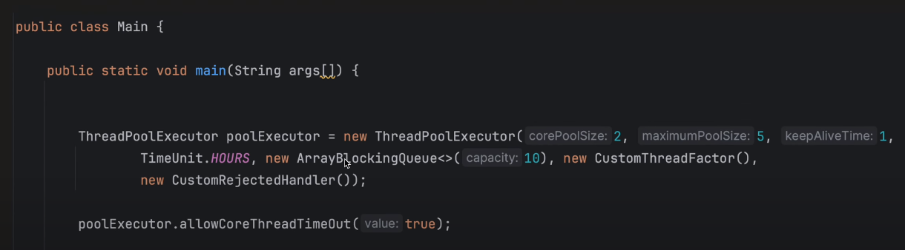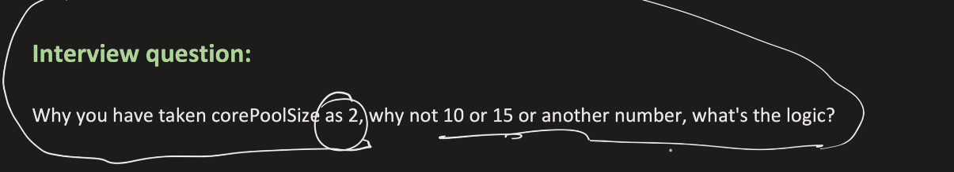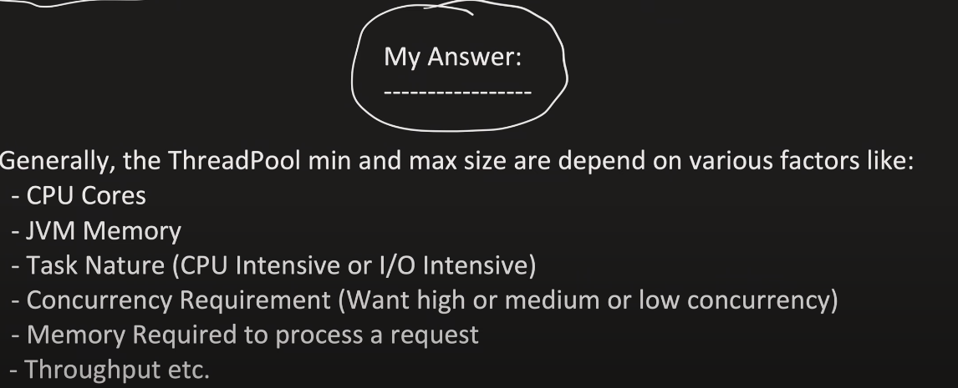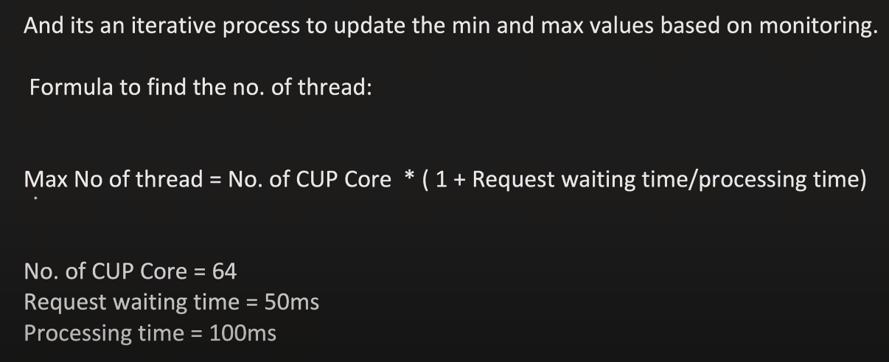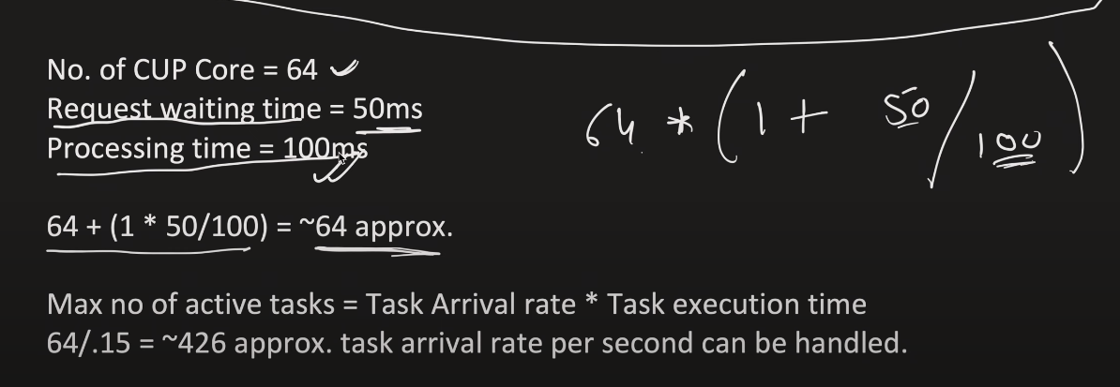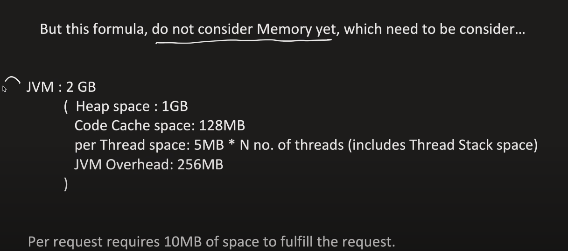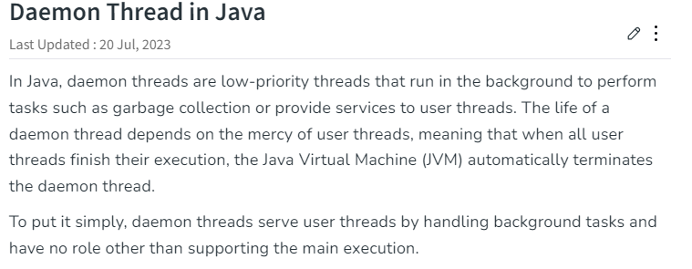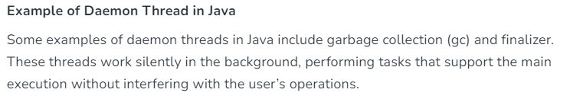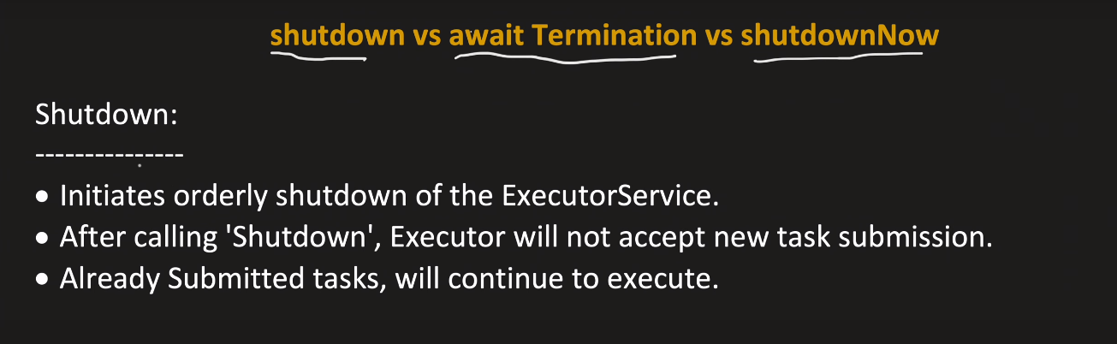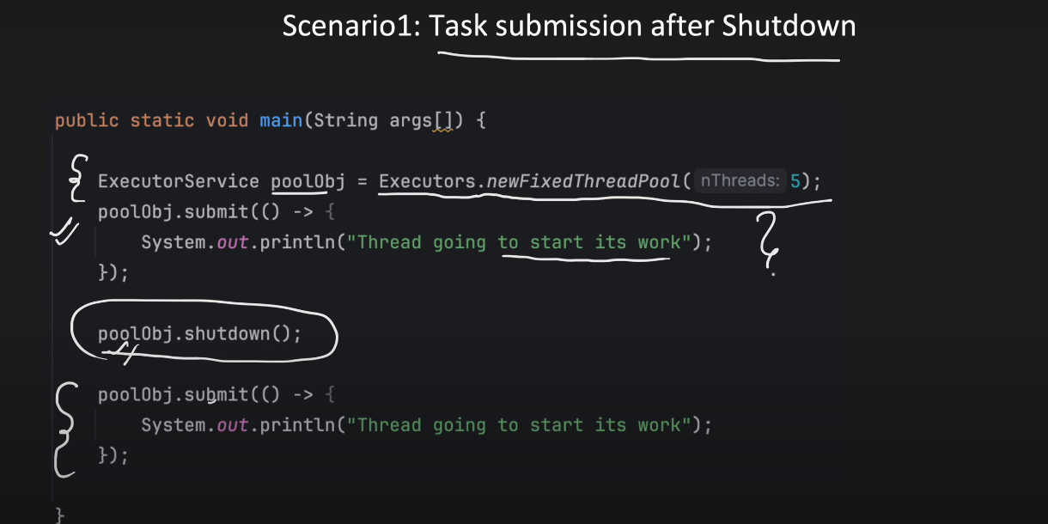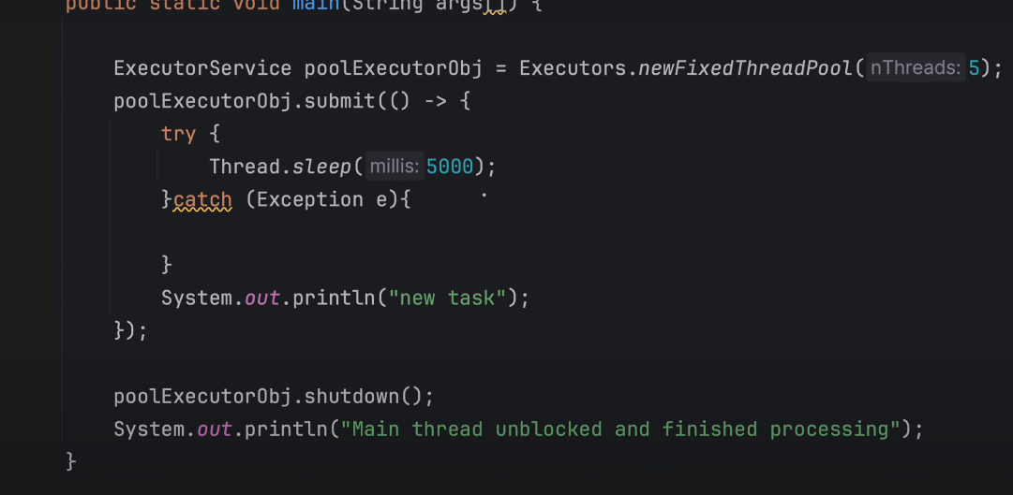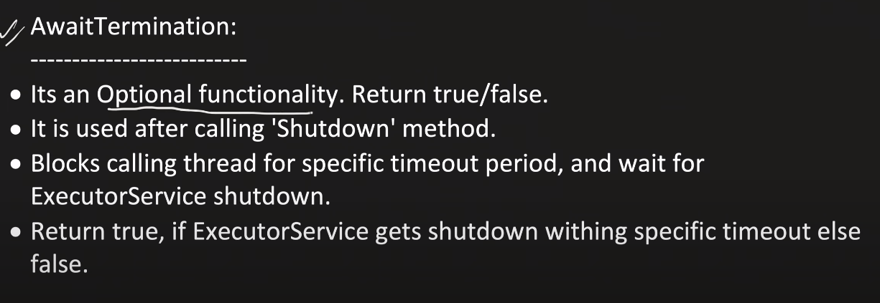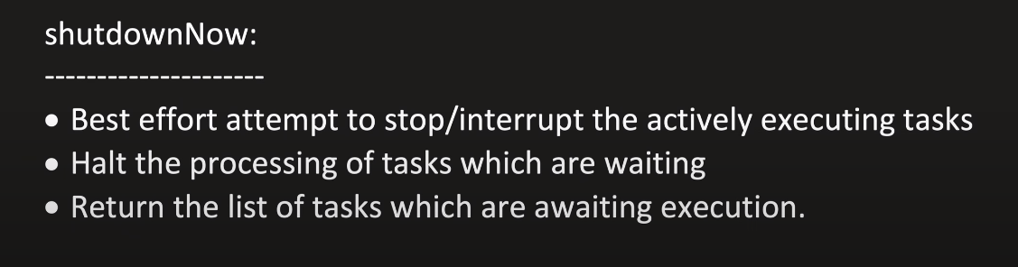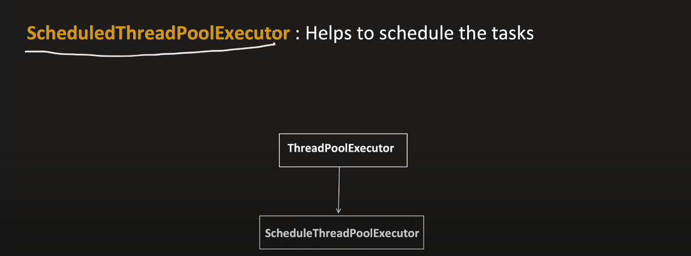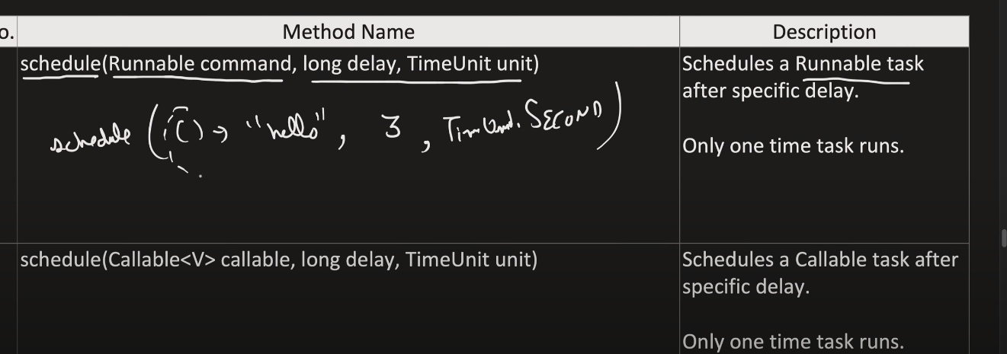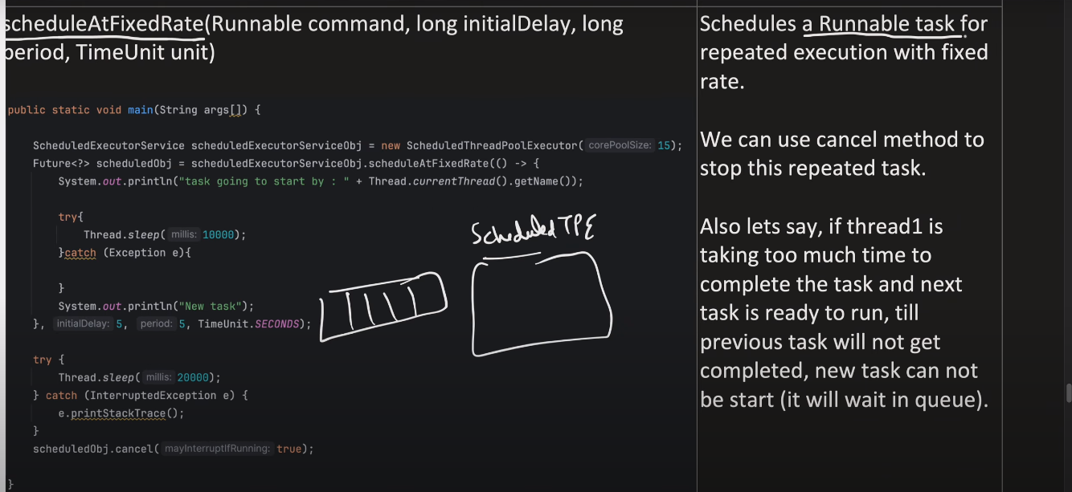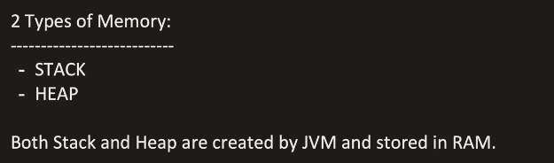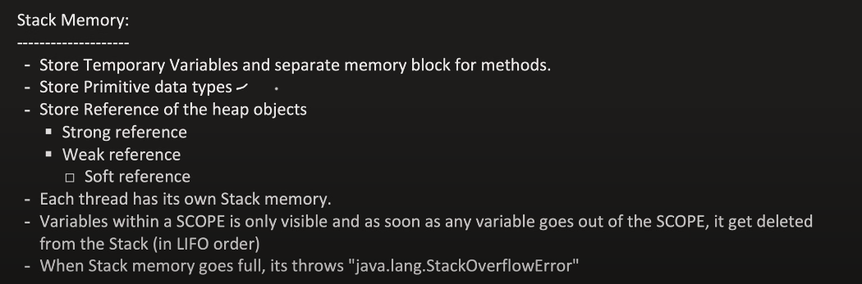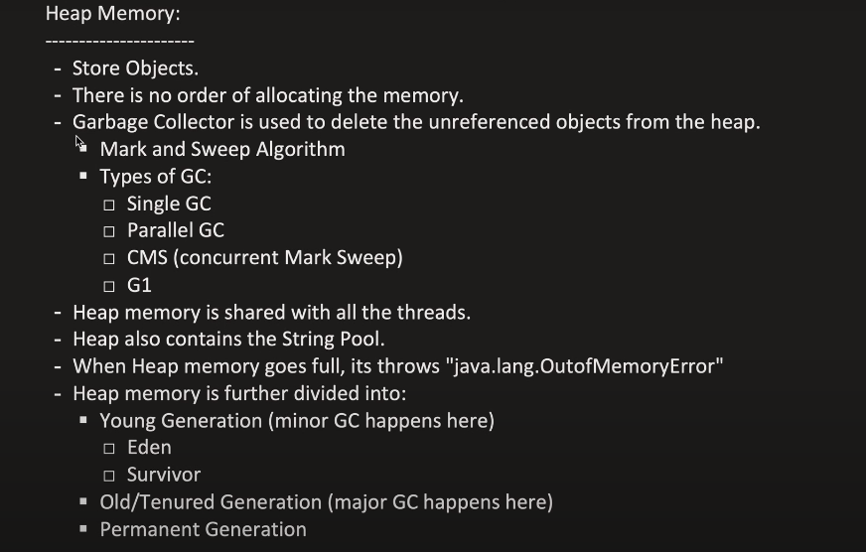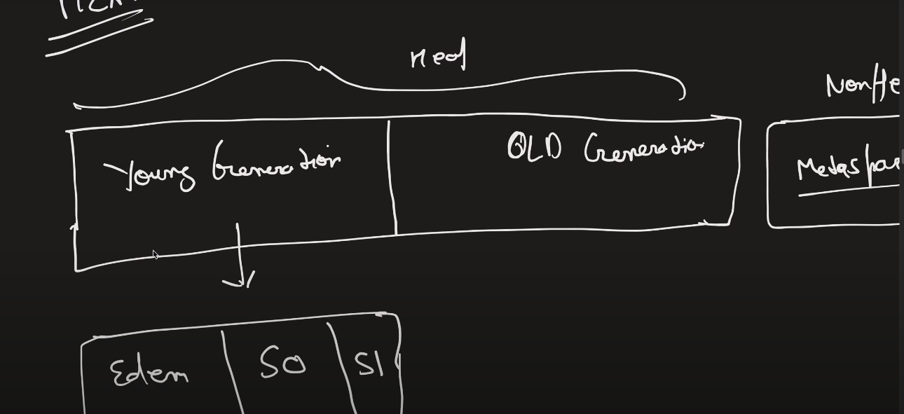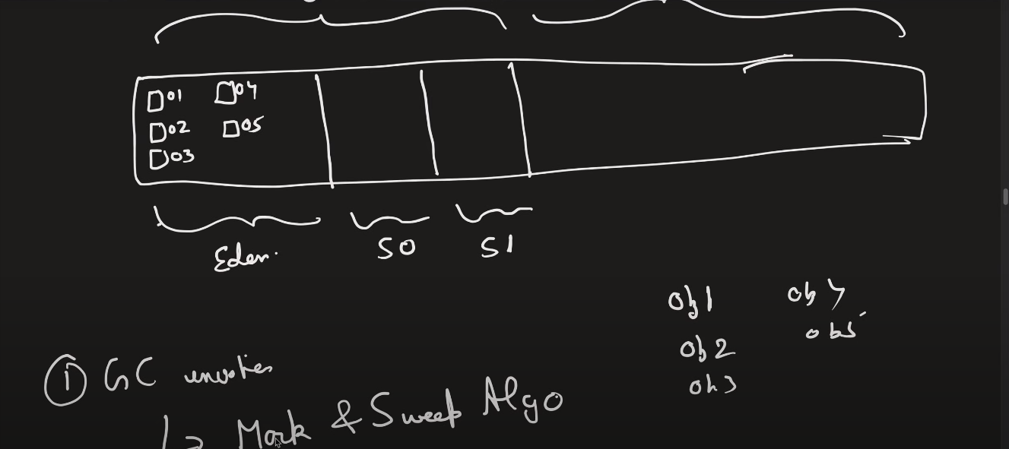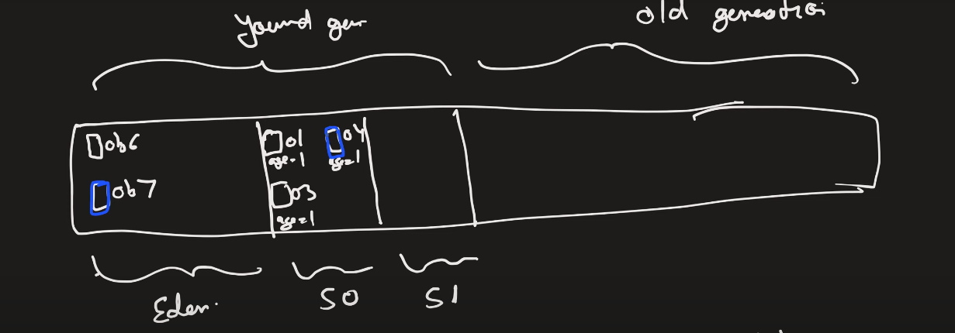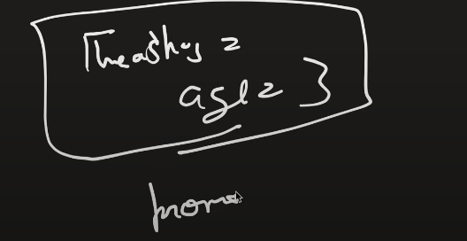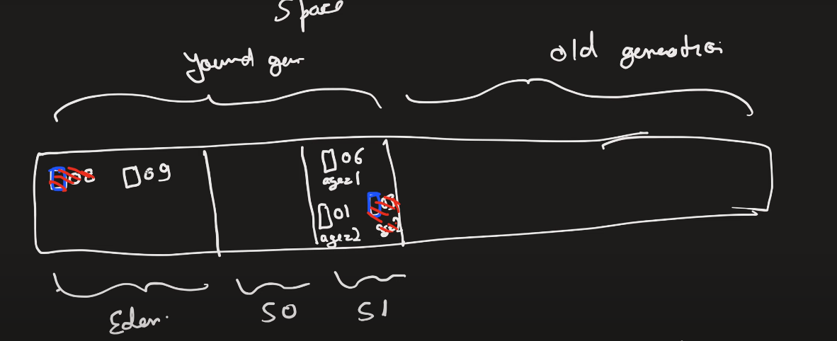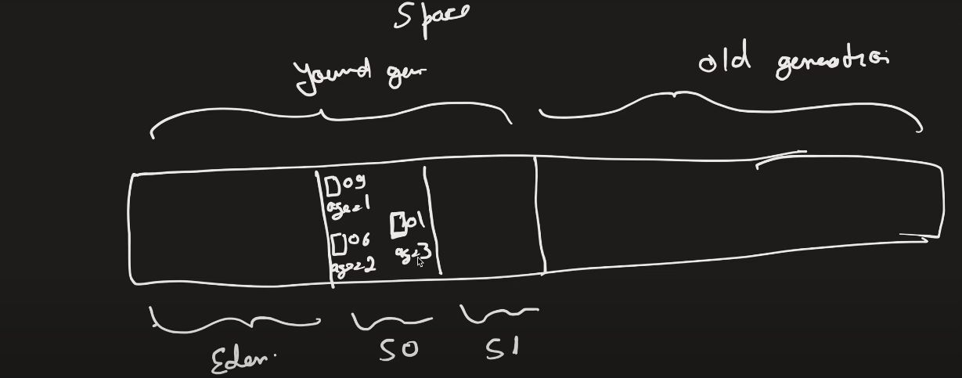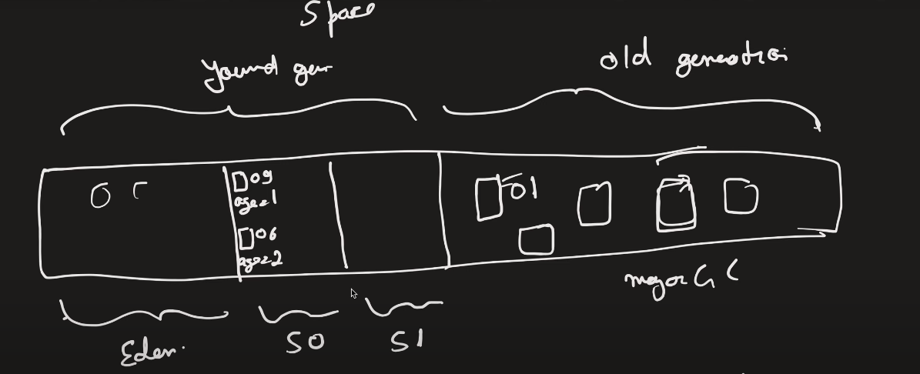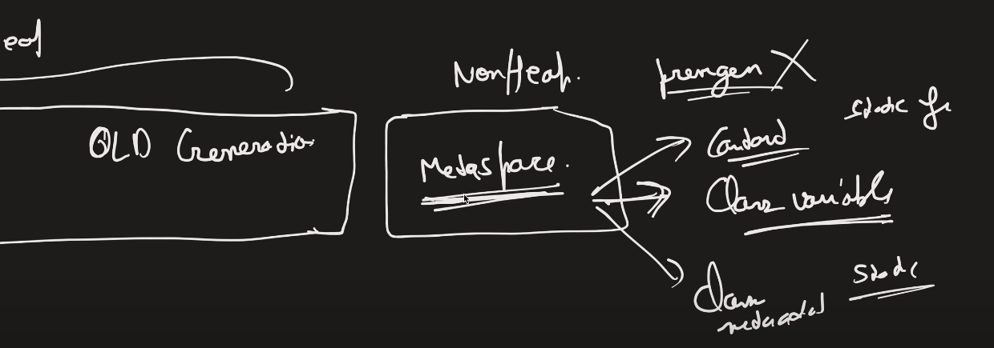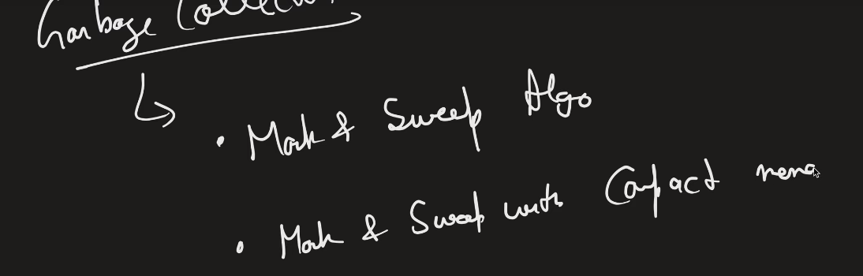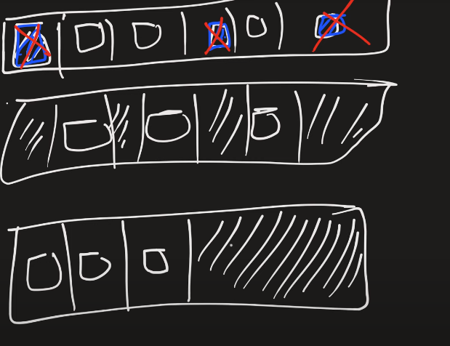With mark and sweep with compaction memoery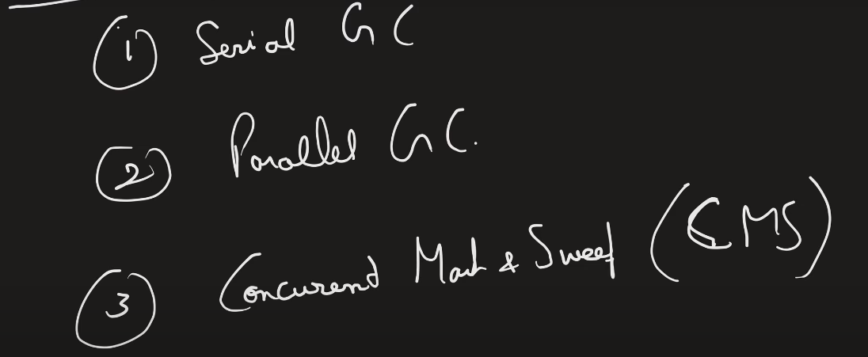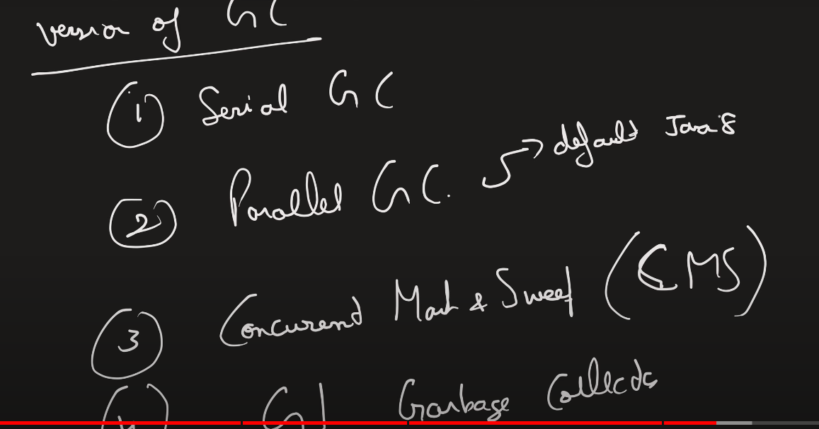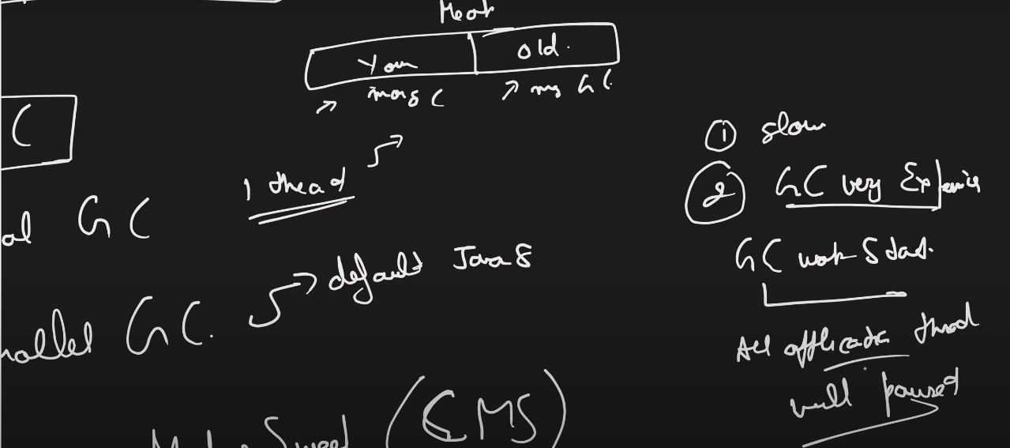GC is expensive when gc thread starts all application thread is paused.

In concurrent mark and sweep gc thread and application thread works concurrently.but it does not gurantee but it will try its best.In g1 gc it gurantees application thread wont stop along with gc thread and it also ensures memory compaction so that remaining memory can be used effectively.

In heap memory objects are stored in young and old gen. young gen is divided into 3 parts eden,s0,s1 basically survivors.and they are set with age threshold so when they reach the threshold limit they are moved to old gen. in young gen it is minor gc that runs periodically lets say in every 10 secs and in old generation it is called major gc that is lets say runs in every half hours . metaspace is used to store class variables ,static and final variables,constants etc outside the heap memory and metadata about the class. Objects are freed up from youn generation and keeps on moving from eden to s0 and s1 depending upon the mark and sweep algorithm of gc.